Matt Fitzpatrick Sits Atop Cosmopolitan Leaderboard
2019, World Golf Championships
Rory McIlroy, the No 2 in the World, is one shot behind Matt Fitzpatrick at the half-way stage of the WGC-HSBC Champions after following one 67 with another.
Both of McIlroy’s rounds featured run of four successive birdies but where, on Day 1, he closed with a bogey six, he signed off from Day 2 with an eagle. Though his drives had gone a little awry on the other par fives, he caught the fairway off the tee at the 538 yards 18th before knocking the ultimate in five-irons to three feet.
This four-time major winner came up with an interesting statistic before moving on to sign autographs. “It’s something I’ve always kept an eye on,” he explained, “but I’ve arrived at the point where I’ve finished in the top ten on the PGA Tour in 50% of the tournaments I’ve played. It wasn’t at that level last year but that’s where it is now.”
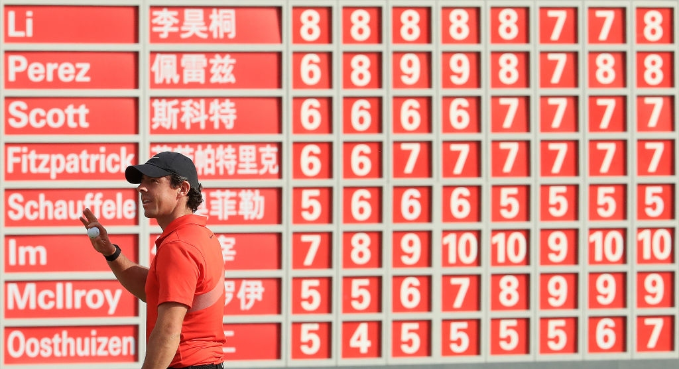
Fitzpatrick, who has had rounds of 66 and 67, was the victim of some strange goings-on at the 16th in his second round. With his ball sitting well down in the fringe at the back of the green, he tried to stab it towards the hole with his putter slightly hooded. As it was, the ball took to the air and had still to come to ground as he completed his follow-through.
The 25 year-old Englishman then holed for a par from 20 feet before signing off with a couple of birdies. For a shot which was at the other end of the spectrum to that unexpected strike at the 16th, he opted for his five-iron to the short 17th. Though the ball finished 15-foot from the hole, it was “all over the flag” all the way.
How Fitzpatrick loves the greens at Sheshan. He was happy enough with the putting surfaces in Japan last week, but these, to put it his way, are “three-feet quicker”. He then owned to liking nothing so much as the kind of super-fast, downhill putts which would give most golfers the heebie-jeebies.
The round over, Fitzpatrick joined Justin Rose and a host of others on the range while Sungjae Im was putting the finishing touches to the second round 69 which left him in a share of third place with Xander Schauffele and Adam Scott.
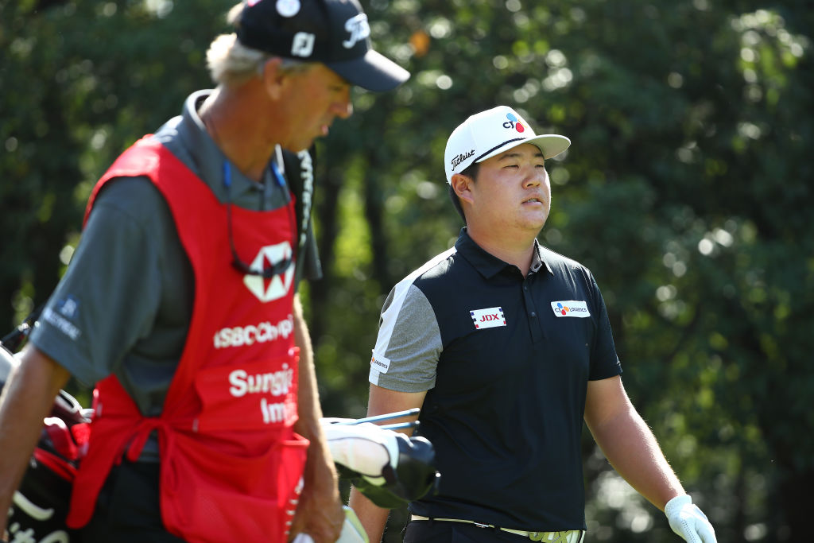
Insofar as that he never stops playing, the 21-year-old Im leaves everyone for dead. Where the average PGA Tour player had competed in 22.8 tournaments going into the Tour Championship at East Lake, he had played 35. Apparently 42 events is the most a man could conceivably find to play, though the chances are that Im will find a way
Were Pia Nilsson, of VISION54 fame, to get hold of the lad, she would be telling him to cut down on the amount of golf he is playing, rather as she has always encouraged the Korean women to take at least one day off per week. Nilsson’s recipe, incidentally, has been one of teaching her Korean students to cook.
Meanwhile, if Schauffele is going to keep up a run in which Americans have won each of the last seven WGCs, he could have his work cut out. In a top eight which could not be more cosmopolitan, he has an Englishman, an Irishman, a Korean, an Australian, a Chinese player, a Frenchman and a South African as his companions.

