‘The Best Golf Lesson Ever’- Global Superstars Surprise Next Generation of Chinese Golfers
2019, CGA-HSBC Junior Golf, China Golf, Ian Poulter, Justin Rose, Li Haotong, Rory McIlroy, Xander Schauffele
Local juniors surprised by elite golfers, including Rory McIlroy, Xander Schauffele and Justin Rose, as the WGC-HSBC Champions swings into action with a celebration of the growth of golf in China
29th October 2019
As the WGC-HSBC Champions in Shanghai celebrates 15 years of world-class golf, tournament title partner HSBC has brought together some of the game’s biggest stars alongside some of its brightest talents for a demonstration of just how far the sport has come in China.
Every year, WGC-HSBC Champions has one of the strongest fields outside of a Major Championship. This year’s tournament continues that trend. With such a strong field, HSBC were able to call on some of the biggest names in golf to deliver a unique experience for some very talented Chinese golfers.
Defending champion Xander Schauffele joined World Number Two Rory McIlroy, former champion and World Number Seven Justin Rose, Ryder Cup legend Ian Poulter and local hero Li Haotong to surprise some of China’s most promising young players – stars of the CGA-HSBC China Junior Golf Program – at the driving range at WGC-HSBC Champions.
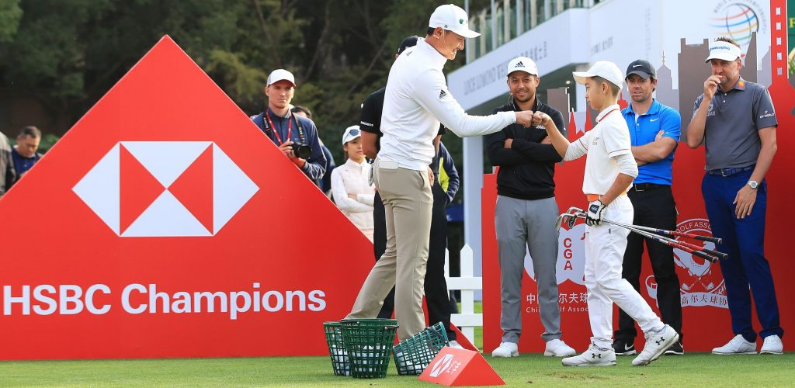
The ‘best golf lessons ever’ were given to five special youngsters, selected from throughout China, as a memorable reward for showing outstanding progress and brilliant performances during the 2019 season of the junior program.
Youngest of all, Xu Zilin, already a proven winner at only 9 years-old, left her coach for the day Ian Poulter completely speechless by her remarkable display. Beijing-based, Chang Xihuan, an 11-year old number 1 ranked youth and nine-time winner of HSBC Junior Championship events made fellow countryman Li Haotong immensely proud. While Ni Zixin, a 12-year from Hubei, showed coach Rory McIlroy ball-striking skills to rival his own!
Not to be outdone by their young counterparts, the experienced 15-year old Tong Yang from Guangdong inspired defending champion Xander Schauffele in their one on one session. While 18-year old Sun Jiaze also of Guangdong showed coach Justin Rose why she might have a gold medal of her own one day.
The players were able to pass on advice and witness first-hand the incredible talent now coming through in Chinese golf. The unique range clinic served as the ideal warm-up for later in the week, when the global stars tackle the testing Par 5 closing 18th hole at Sheshan International Golf Club with the talented youngsters playing alongside.
In a final surprise, the elite golfers invited the kids to join them as VIPs on the red carpet at the WGC-HSBC Champions welcome dinner. A truly unique experience that is sure to inspire the youngsters to continue to chase their golfing dreams. 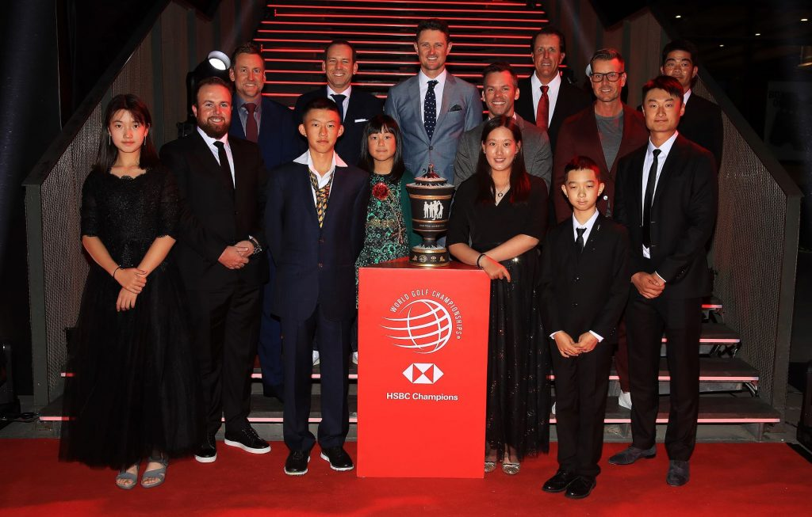
The activity highlights the long-term commitment of tournament partner HSBC to supporting the growth of golf all over China. The CGA-HSBC China Junior Golf Program was created in 2007 as a sustainable long-term structure and framework for the future of Chinese golf. The programme is the only officially sanctioned junior golf programme in China.
In 2006 there were only 406 registered junior golfers in China, while in 2019, the figure stands at over 60,000 registered junior golfers with overall junior participation around 700,000. Over the past 12 years, the CGA-HSBC China Junior Golf Programme has put golf clubs in the hands of well over 100,000 children through junior golf tournaments, golf training camps and school initiatives, helping to guide the elite and inspire a thriving new community of players.
Already a number of the juniors that were introduced to the game through these HSBC programmes have gone on to forge successful careers in the game and will compete in this week’s WGC-HSBC Champions. Local favourites Li Haotong, T7th in 2010, and Dou Zecheng, four-time winner on the PGA Tour China, will both be playing. A remarkable total of 5 of the 7 Chinese players in the tournament field all developed their games as members of the CGA-HSBC China Junior Golf Program.
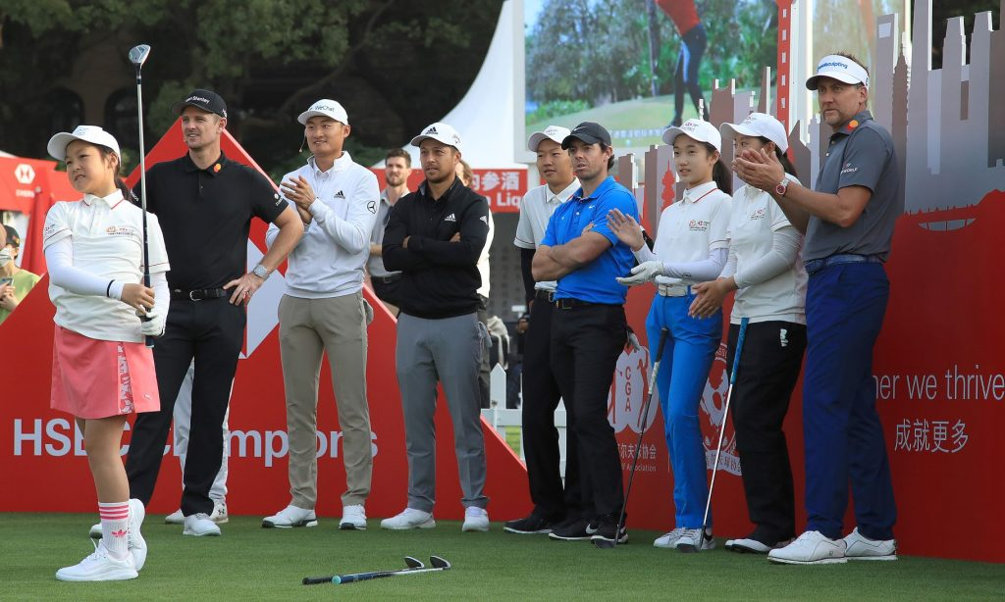
Li Haotong, former graduate of the CGA-HSBC China Junior Golf Program spoke about the experience: “When the first WGC-HSBC Champions took place in 2005 I was just nine years old. In that time, it has been incredible to be part of a huge rise in interest in golf in China. I am extremely proud to see the growth of the game I love and to see so many kids coming through. It was a privilege to connect with some of the future stars of Chinese golf today and hopefully help set them off on their own golfing journeys.”
Rory McIlroy, who has finished in the top five on three previous occasions, said: “Whenever you play WGC-HSBC Champions you feel like the eyes of the entire country are on you. It’s great to compete in front of this growing and energetic audience of golf fans who are extremely knowledgeable and committed to the game. All the work that has been done to support golf in the country is certainly paying off, both in the growth of the fanbase and the talented young golfers we met today.”
Schauffele, an American whose Chinese-speaking mother witnessed his victory in Shanghai last year, said: “WGC-HSBC Champions will always hold a special place in my heart having won last year in front of my family. It’s great to be back and to be able to meet some of these young Chinese stars. Thanks to the work done to encourage the game here in China there is now a really strong pool of talented players across the country and I’m sure that some of the kids I met today will be winning global tournaments before we know it.”
Jonathan Castleman, HSBC’s Global Head of Brand Partnerships, said: “The WGC-HSBC Champions is a truly unique tournament that brings the eyes of all of China, as well as the wider sporting world, on to Chinese golf. We have long been committed to supporting golf in China, believing strongly in the values and relationship-building benefits the sport can bring to individuals and businesses. The CGA-HSBC China Junior Golf Program in particular is the source of great pride for us as a business. We are delighted to continue to support the next generation of talent in China and look forward to experiencing another great showcase of the growth of Chinese golf this week.”
For more details on the WGC-HSBC Champions and all ticket information, please click here or follow our official WeChat Mini Program: HSBCChampions
