McIlroy Gets The Best Out Of Himself
2019, Rory McIlroy, Xander Schauffele
After Rory McIlroy had defeated America’s Xander Schauffele at the first extra hole in the WGC-HSBC Champions at Sheshan, he came up with a message for China’s budding golfers. After mentioning how much belief his mother and father had instilled in him from an early age, he said they needed to be like him in never doubting their ability.
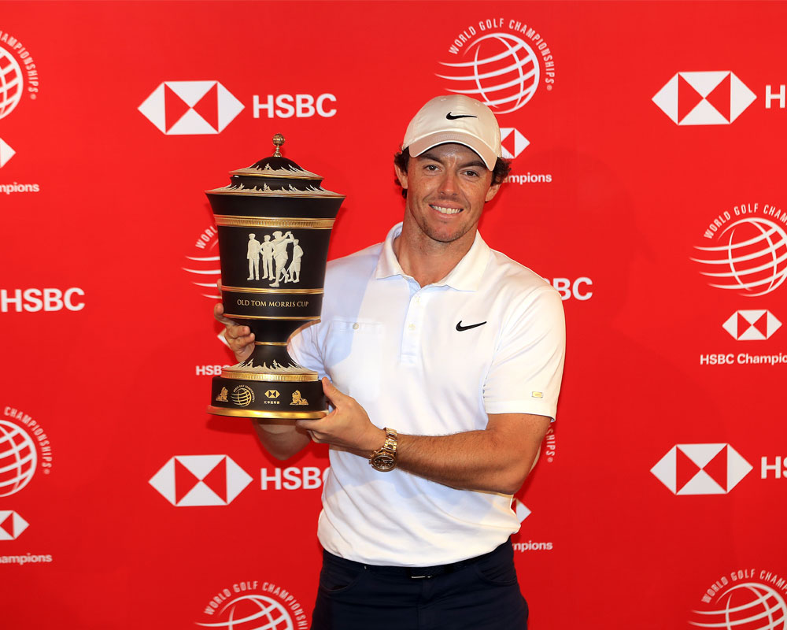
“Even what’s beyond your wildest dreams can be possible,” he told them. “People said to me I that I wasn’t big enough and things like that, but I went ahead and ended up doing what I set out to do.”
This popular winner had seemed set to tie up what would be his fourth title of the season at the long 72nd, at which point he was 19 under par to Schauffele’s 18 under. However, after delaying before he hit from the tee while he watched where the defending champion’s drive had landed, he hit towards the lake on the right.
Having thought that the ball had splashed into the depths, he was not as disappointed as he might have been and, as a result, embarked on the play-off in good heart.
As per usual, the play-off involved returning to the 18th tee, and, this time, followed the best of drives with a second which caught the green precisely where he had envisaged en route to his winning four. It was, he said, a great example of what he has learned over the years “about getting the best out of myself when I need it.”
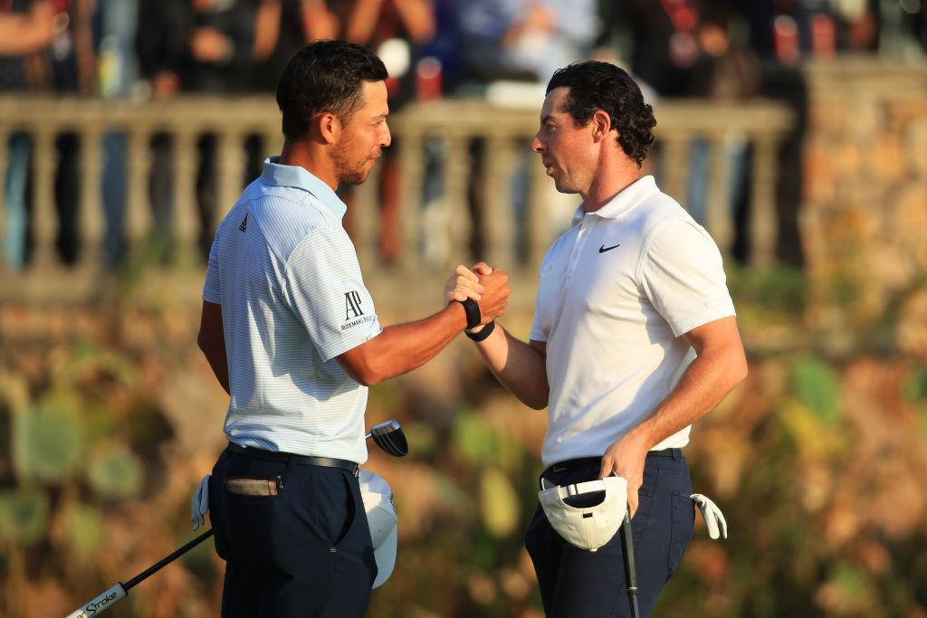
Schauffele, for his part, more or less ruined his chance of winning for a second successive year by pulling his tee shot into the rough on the left.
Not, mind you, the American would ever have believed that he would have had so thrilling a week after he had had to pull out of the pro-am on Wednesday feeling “very sick”. The locals, though, were never inclined to rule him out, noting as they did that he had “a strong heart” to make up for the bug that had invaded his system.
Louis Oosthuizen, who had been lying a shot behind McIlroy overnight, had been in fine fettle at the start of the day. Not only was he fielding congratulations galore on account of the South African’s historic win in the World Cup final, but he started from home with back-to-back birdies to go one ahead of McIlroy at 16 under to his 15 under. But while Schauffele, in the same leaders’ trio, went from strength to strength, Oosthuizen started to fall away with a drive which needed to be hacked out of the woods at the ninth. Unlike Schauffele, this former Open champion then missed the birdie putts which could have seen him sharing in the extra-holes outing.
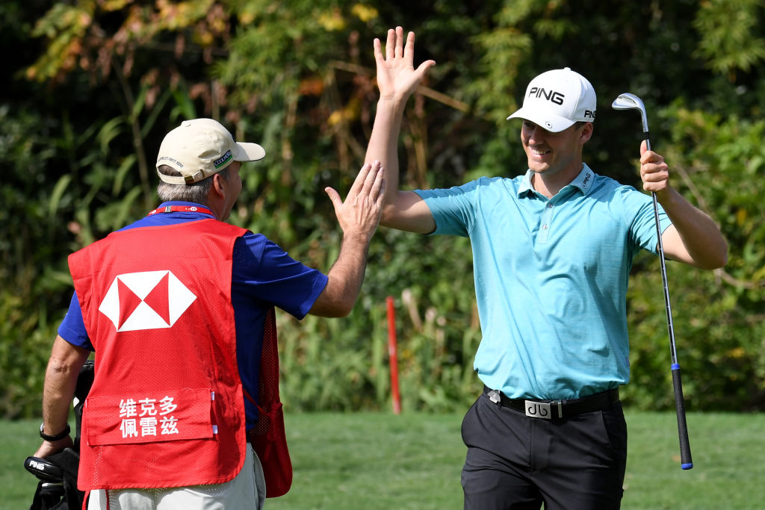
McIlroy was not alone in feeling like a winner, Victor Perez, who came from nowhere to win the Dunhill Links championship at the end of September, had scores of 65, 71,71 and 66 to finish in a share of fourth place in what was his first outing in such illustrious company.
The putts refused to drop in the third round but he changed nothing and, sure enough, everything came right in a final round which he started with four birdies in his first six holes. Now, he is on his way to Turkey with the stars and, still more importantly, he will be playing alongside McIlroy in the DP World Championship in Dubai.

