Golf: Team Sport or Individual Game
2019, Brooks Koepka, Francesco Molinari, Justin Rose, WGC
There are not too many sports where a team consists of as few or as many members as anyone wants, but in golf it could be any number from, say, Brooke Koepka’s three to Justin Rose’s eight. Francesco Molinari, meantime, has known both scenarios. He had a team of three which swelled to eight three or four years ago as he surrounded himself with a host of experts.
Yet it remains strange that golf should be referred to a team game at all when it is essentially an individual sport, one which people can play on their own without having to ring round for an opponent.
Years ago, at a professional tournament, there would be no more than a player and his caddie and, if any complaining needed to be done on behalf of the player, it would most likely be undertaken by a player’s wife. Back in the 1950s and 1960s, for example, Harry Weetman’s wife, Freda, would speak up at once if, say, the captain of a GB&Ireland Ryder Cup side gave her husband a four-ball partner of whom she did not approve.
Caddies of old would have had no trouble in describing themselves and their players as a team. But it was seldom less than a pretty fickle arrangement in that it only took a single mistake on a player’s part for his caddie to disown him. The royal ‘we’ which the caddie might have used to boast of a quartet of birdies on the front nine – “We made four birdies in a row” – would be dropped at once when the supposed star went off the rails. Then, the caddie’s most likely utterance would be an exasperated, “He made a right hash of things.”
Loyalty is of the essence in the modern golfer’s team and there is no question that the degree of support that comes with it can make all the difference to the player’s feel-good factor.
As to who comes where in the modern team line-up, you would be wrong to assume that the player will always be at the top of the tree.
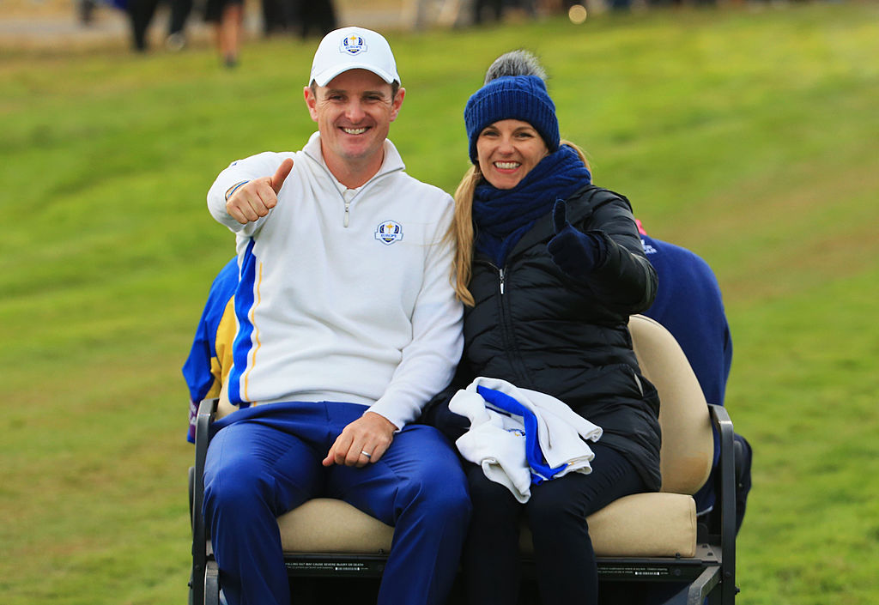
Shades of the Weetman days, it is Kate Rose, Justin’s wife, who is labelled, “The Boss” of ‘Team Rose’. From the family home in the Bahamas, she runs the Kate and Justin Rose Foundation – a job which has recently been asking rather more harrowing questions than any golf event as the foundation provides ongoing support to victims of the hurricane.
To run through the other members of ‘Team Rose’, the player’s coach of the moment is Sean Foley, who at one time worked with Tiger Woods; the caddie is Gareth Lord, who took over from Mark Fulcher when the latter needed a heart operation two years ago; and the personal trainer is Justin Buckthorpe, a health and performance specialist par excellence.
The list has a bit to go… Phil Kenyon is the putting coach and just how good a putting coach can be explained with the news that he was working with as many as seven of the twelve European players at the 2018 Ryder Cup. Next comes Jason Goldsmith, a mental game expert who is a whizz when it comes to sharpening a player’s focus and quietening his mind. And, finally, there is Dr Brendan McLaughlin, a renowned chiropractor.
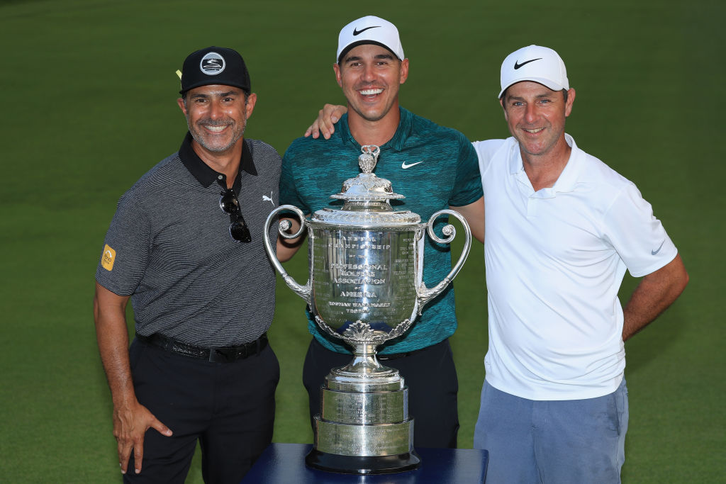
Different players have different needs and it suits Koepka to keep his mini-team a mini affair. He has stayed with the same coach, albeit a very special one, in Claude Harman, and has a caddie by name of Rickie Elliot who doesn’t get much wrong.
Koepka will tell you that Harman’s main strength is that he only makes suggestions when they are 100% necessary. (Usually, they will be related to his set-up.) For the rest of the time, he will give nothing more than an approving nod and send his player out on the course with his confidence at a high.
Elliot’s contribution, apart from carrying the bag, is to back Brooks all the way. “It’s only the two of us who want me to win and he never lets me down on that score,” said Koepka.
Every now and then, a player will come up with a particularly unlikely team member. Ian Woosnam, for example, had a magician called Jamil Qureshi among his team of captain’s helpers at the 2008 European Ryder Cup in Ireland, Qureshi would have had no trouble in producing rabbits from hats and, just as surely, he turned himself from magician to one of the most highly respected psychologists in golf. He had an extraordinary way with him when it came to de-stressing a player.
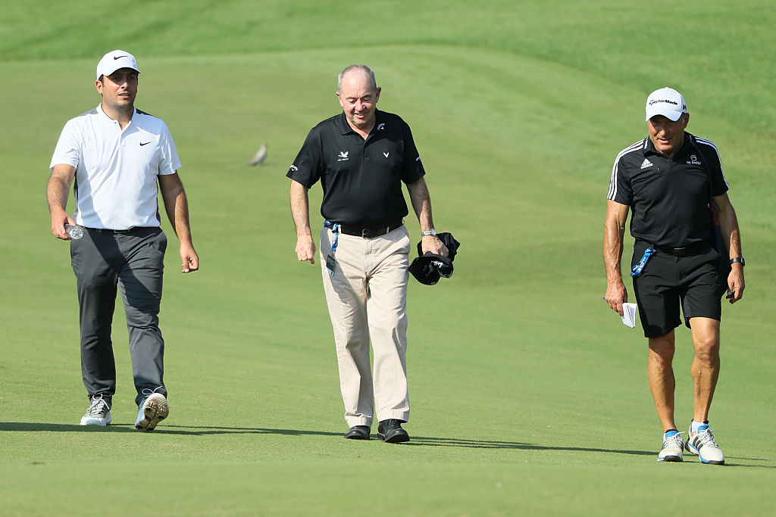
Meanwhile, Molinari added an England rugby coach to his side ahead of his 2018 Open championship win at Carnoustie.
Dave Alred used to tell rugby’s goal-kickers, “If you want to hit through the door, aim at the key-hole.” The advice worked as well in golf as it did in rugby, with Molinari learning to deliver one short iron after another within a six-foot ring of the hole – a result to prompt thoughts as to whether Alred, like Qureshi, was a member of The Magic Circle.

