McIlroy Leads The Way
2019, Li Haotong, Louis Oosthuizen, Rory McIlroy, WGC, World Golf Championships
The sun was going down and so, too, were the putts on the third day of the WGC-HSBC Champions at Sheshan. Every member of the top four made a birdie putt at the 18th, with Rory McIlroy closing the day with a three-footer for the third of the three 67s which left him a shot ahead of Louis Oosthuizen.
The South African had got off to much the racier start. Seven under par when he teed off to McIlroy’s ten under, he galloped up the leaderboard with five opening birdies on his way to the round of the day, a 65.
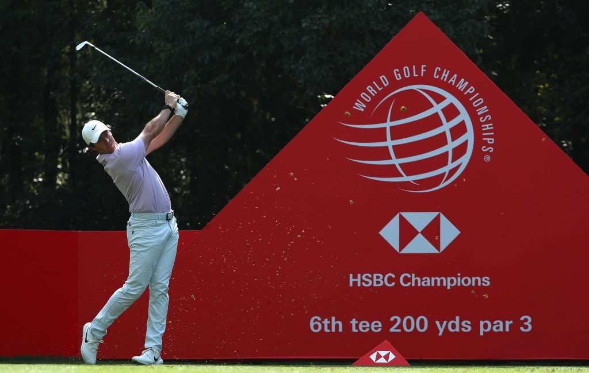
It was McIlroy’s manager who had suggested on Friday night that if his player were to hand in a couple more 67s he should get the job done.
The World No. 2 was only one under par for his first five as against Oosthuizen’s five under, but he seized the birdie chances as and when they came. There was the thought that he might do as many another in trying for the green at the 288 yards 16th but, after he had watched Matt Fitzpatrick’s ball slipping into the green-side bunker, he went for the safe option: “It’s fun to try and test myself at times, but sometimes you have to realise that the prudent play is to lay it up on the fairway and give yourself a chance from there… So though there are times when it hurts to play safe, most of the time it’s for a very good reason.”
Bearing in mind what he said about learning from his recent win in Canada where, after going into the last round with a share of the lead, he decided to keep his foot down all the way, it will be interesting to see what he does at a hole such as the 16th in Round 4.
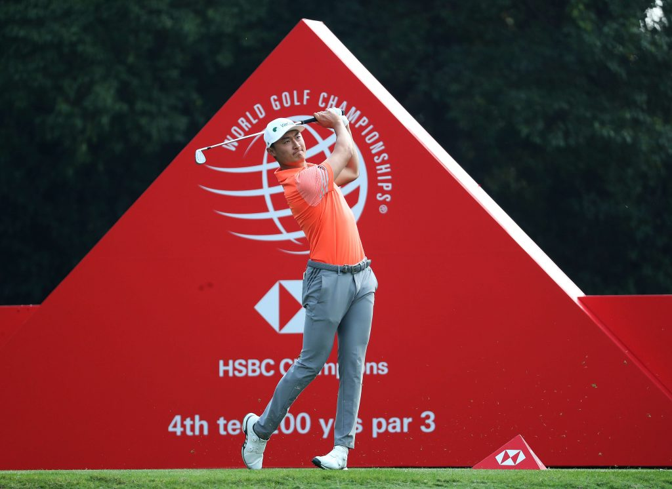
It goes without saying that when Haotong Li set sail with five birdies in his first six holes, the whole of Sheshan was buzzing with the news. Alas, the popular local found trouble down the long eighth by way of a first hiccup. He was still looking like a potential winner after an outward 32 but, to all round shock, he needed ten shots more for the second nine, with most of the damage being done with a seven at the 13th.
McIlroy was asked if he was surprised that Oosthuizen had not won more in a career in which he was at one point the No 4 in the world. The Ulsterman’s response was that if golf was just about the golf swing, Oosthuizen would be topping them all as the No 1. “It’s just that there are so many different elements to the game. Winning’s hard but Louis obviously won the Open of 2010 at St Andrews.”
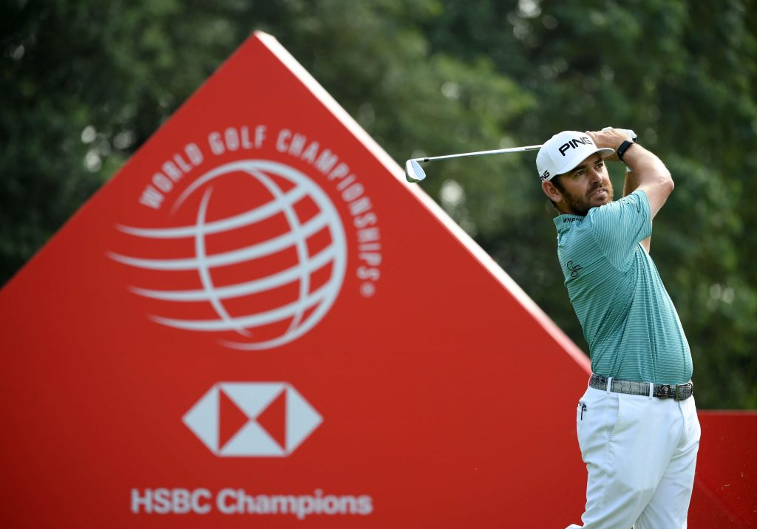
You ask Oosthuizen to pick out the shot from what was that 150th Open which comes to mind the most often and he goes for the 40-foot eagle putt he holed at the ninth in the final round. He had started the day four shots clear but, with Paul Casey was beginning to give effective chase, he felt the need to put him in his place. That 40-footer did the trick – and he went on to win by seven.
By way of a bit of relaxation, though it was not necessarily going to be that, Oosthuizen hurried back to his hotel to watch South Africa v England in the final of the World Cup.

